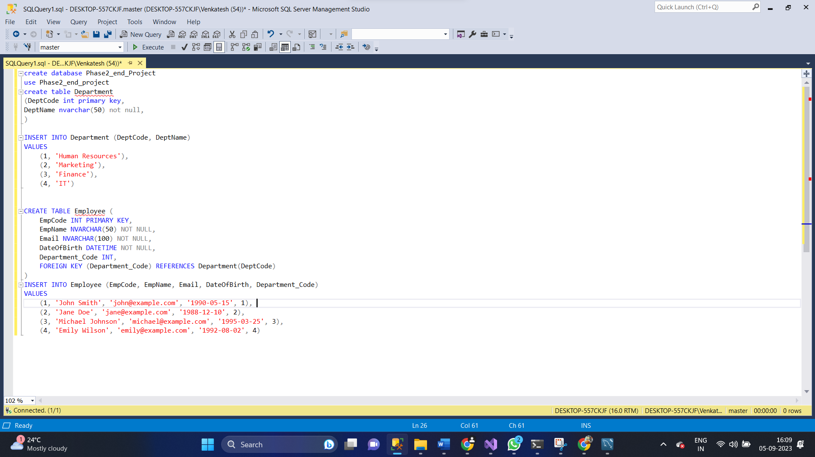**Source Code**

* **Department Code**

using System;

using System.Collections.Generic;

namespace project1.Models;

public partial class Department

{

public int DeptCode { get; set; }

public string DeptName { get; set; } = null!;

public virtual ICollection<Employee> Employees { get; set; } = new List<Employee>();

}

* **Employee Code**

using System;

using System.Collections.Generic;

namespace project1.Models;

public partial class Employee

{

public int EmpCode { get; set; }

public string EmpName { get; set; } = null!;

public string Email { get; set; } = null!;

public DateTime DateOfBirth { get; set; }

public int? DepartmentCode { get; set; }

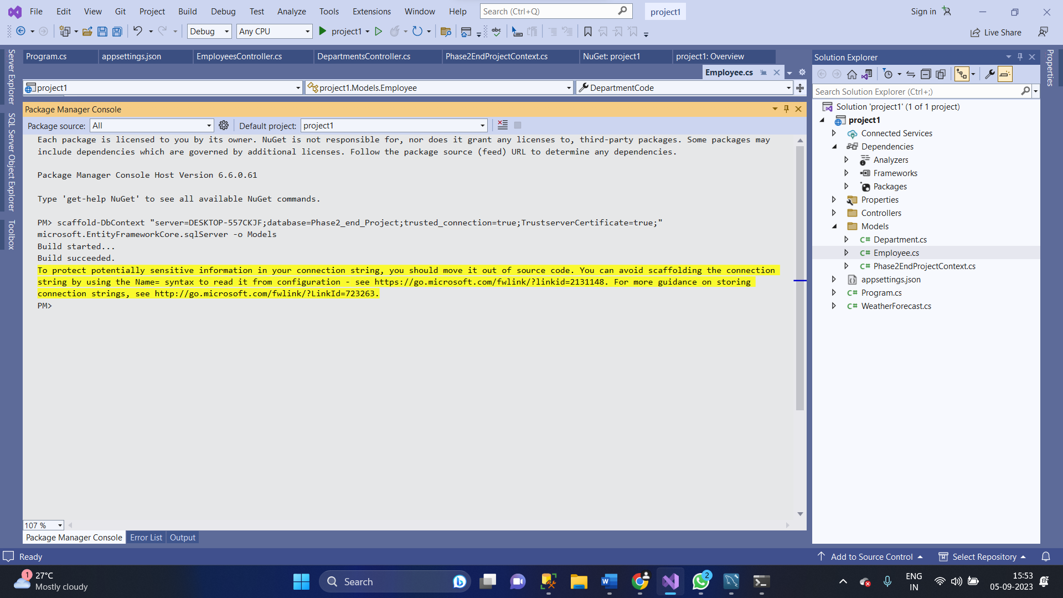 public virtual Department? DepartmentCodeNavigation { get; set; }}

* **DepartmentController Code**

using System;

using System.Collections.Generic;

using System.Linq;

using System.Threading.Tasks;

using Microsoft.AspNetCore.Http;

using Microsoft.AspNetCore.Mvc;

using Microsoft.EntityFrameworkCore;

using project1.Models;

namespace project1.Controllers

{

[Route("api/[controller]")]

[ApiController]

public class DepartmentsController : ControllerBase

{

private readonly Phase2EndProjectContext _context;

public DepartmentsController(Phase2EndProjectContext context)

{

_context = context;

}

// GET: api/Departments

[HttpGet]

public async Task<ActionResult<IEnumerable<Department>>> GetDepartments()

{

if (_context.Departments == null)

{

return NotFound();

}

return await _context.Departments.ToListAsync();

}

// GET: api/Departments/5

[HttpGet("{id}")]

public async Task<ActionResult<Department>> GetDepartment(int id)

{

if (_context.Departments == null)

{

return NotFound();

}

var department = await _context.Departments.FindAsync(id);

if (department == null)

{

return NotFound();

}

return department;

}

// PUT: api/Departments/5

// To protect from overposting attacks, see https://go.microsoft.com/fwlink/?linkid=2123754

[HttpPut("{id}")]

public async Task<IActionResult> PutDepartment(int id, Department department)

{

if (id != department.DeptCode)

{

return BadRequest();

}

_context.Entry(department).State = EntityState.Modified;

try

{

await _context.SaveChangesAsync();

}

catch (DbUpdateConcurrencyException)

{

if (!DepartmentExists(id))

{

return NotFound();

}

else

{

throw;

}

}

return NoContent();

}

// POST: api/Departments

// To protect from overposting attacks, see https://go.microsoft.com/fwlink/?linkid=2123754

[HttpPost]

public async Task<ActionResult<Department>> PostDepartment(Department department)

{

if (_context.Departments == null)

{

return Problem("Entity set 'Phase2EndProjectContext.Departments' is null.");

}

_context.Departments.Add(department);

try

{

await _context.SaveChangesAsync();

}

catch (DbUpdateException)

{

if (DepartmentExists(department.DeptCode))

{

return Conflict();

}

else

{

throw;

}

}

return CreatedAtAction("GetDepartment", new { id = department.DeptCode }, department);

}

// DELETE: api/Departments/5

[HttpDelete("{id}")]

public async Task<IActionResult> DeleteDepartment(int id)

{

if (_context.Departments == null)

{

return NotFound();

}

var department = await _context.Departments.FindAsync(id);

if (department == null)

{

return NotFound();

}

_context.Departments.Remove(department);

await _context.SaveChangesAsync();

return NoContent();

}

private bool DepartmentExists(int id)

{

return (_context.Departments?.Any(e => e.DeptCode == id)).GetValueOrDefault();

}

}

}

* **EmployeeController Code**

using System;

using System.Collections.Generic;

using System.Linq;

using System.Threading.Tasks;

using Microsoft.AspNetCore.Http;

using Microsoft.AspNetCore.Mvc;

using Microsoft.EntityFrameworkCore;

using project1.Models;

namespace project1.Controllers

{

[Route("api/[controller]")]

[ApiController]

public class EmployeesController : ControllerBase

{

private readonly Phase2EndProjectContext _context;

public EmployeesController(Phase2EndProjectContext context)

{

_context = context;

}

// GET: api/Employees

[HttpGet]

public async Task<ActionResult<IEnumerable<Employee>>> GetEmployees()

{

if (_context.Employees == null)

{

return NotFound();

}

return await _context.Employees.ToListAsync();

}

// GET: api/Employees/5

[HttpGet("{id}")]

public async Task<ActionResult<Employee>> GetEmployee(int id)

{

if (_context.Employees == null)

{

return NotFound();

}

var employee = await _context.Employees.FindAsync(id);

if (employee == null)

{

return NotFound();

}

return employee;

}

// PUT: api/Employees/5

// To protect from overposting attacks, see https://go.microsoft.com/fwlink/?linkid=2123754

[HttpPut("{id}")]

public async Task<IActionResult> PutEmployee(int id, Employee employee)

{

if (id != employee.EmpCode)

{

return BadRequest();

}

_context.Entry(employee).State = EntityState.Modified;

try

{

await _context.SaveChangesAsync();

}

catch (DbUpdateConcurrencyException)

{

if (!EmployeeExists(id))

{

return NotFound();

}

else

{

throw;

}

}

return NoContent();

}

// POST: api/Employees

// To protect from overposting attacks, see https://go.microsoft.com/fwlink/?linkid=2123754

[HttpPost]

public async Task<ActionResult<Employee>> PostEmployee(Employee employee)

{

if (_context.Employees == null)

{

return Problem("Entity set 'Phase2EndProjectContext.Employees' is null.");

}

_context.Employees.Add(employee);

try

{

await _context.SaveChangesAsync();

}

catch (DbUpdateException)

{

if (EmployeeExists(employee.EmpCode))

{

return Conflict();

}

else

{

throw;

}

}

return CreatedAtAction("GetEmployee", new { id = employee.EmpCode }, employee);

}

// DELETE: api/Employees/5

[HttpDelete("{id}")]

public async Task<IActionResult> DeleteEmployee(int id)

{

if (_context.Employees == null)

{

return NotFound();

}

var employee = await _context.Employees.FindAsync(id);

if (employee == null)

{

return NotFound();

}

_context.Employees.Remove(employee);

await _context.SaveChangesAsync();

return NoContent();

}

private bool EmployeeExists(int id)

{

return (_context.Employees?.Any(e => e.EmpCode == id)).GetValueOrDefault();

}

}

}